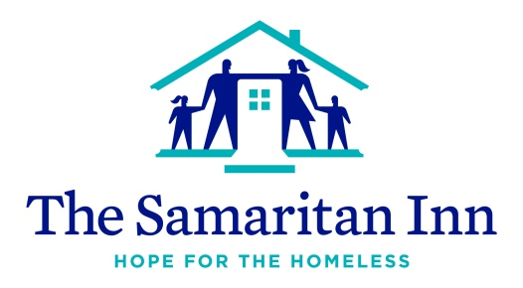
Homeless Awareness Week : November 18-22
Fill the Truck Donation List

Paper Goods
Toilet Paper
Paper Towels

Health Items
Cough Drops

Cleaning Supplies
Multipurpose Cleaner
Simple Green Floor Cleaner
Disinfectant Spray

Can Goods/Cereal/Pasta
Dry Pasta
Pasta Sauce
Can Soups – cream of chicken, cream of mushroom
Can Baked Beans
Box Cereal
Kids Snack Items

Fresh Foods:
Luncheon Meat
Bacon
Breakfast Sausage
Sandwich Cheese

Beverages:
Juice Boxes

